**Department of Computer Science & Engineering, SDMCET, Dharwad-2**



**AOOP Assignment Submission Report**

**[Submitted as part of CTA Assignment No-1]**

|  |  |  |  |
| --- | --- | --- | --- |
| Course: | Advanced Object-Oriented Programming | Course Code: | 18UCSE508 |
| Semester: | V | Division: | A |

Submitted by:

|  |  |  |  |
| --- | --- | --- | --- |
| USN: | 2SD20CS080 | Name: | Prathama M Hegde |

1. **Problem definition:**

1.Write a Java program to generate and handle any three built-in exceptions and display appropriate error messages.

1. **Java Program:**

public class Assignment1{

public static void main(String[] args){

int a=10;

int b=5;

int c=5;

String s=null;

int d[]=new int[5];

try{

System.out.println(a/(b-c));

} catch(ArithmeticException ae){

System.out.println("division by zero error"+ae);

}

try{

System.out.println(s.length());

}

catch(NullPointerException ne){

System.out.println("String is null"+ne);

}

try{

d[10]=50;

}

catch(ArrayIndexOutOfBoundsException aoe){

System.out.println("array index exceeded"+aoe);

}

}

}

1. **Screenshot of excecution:**

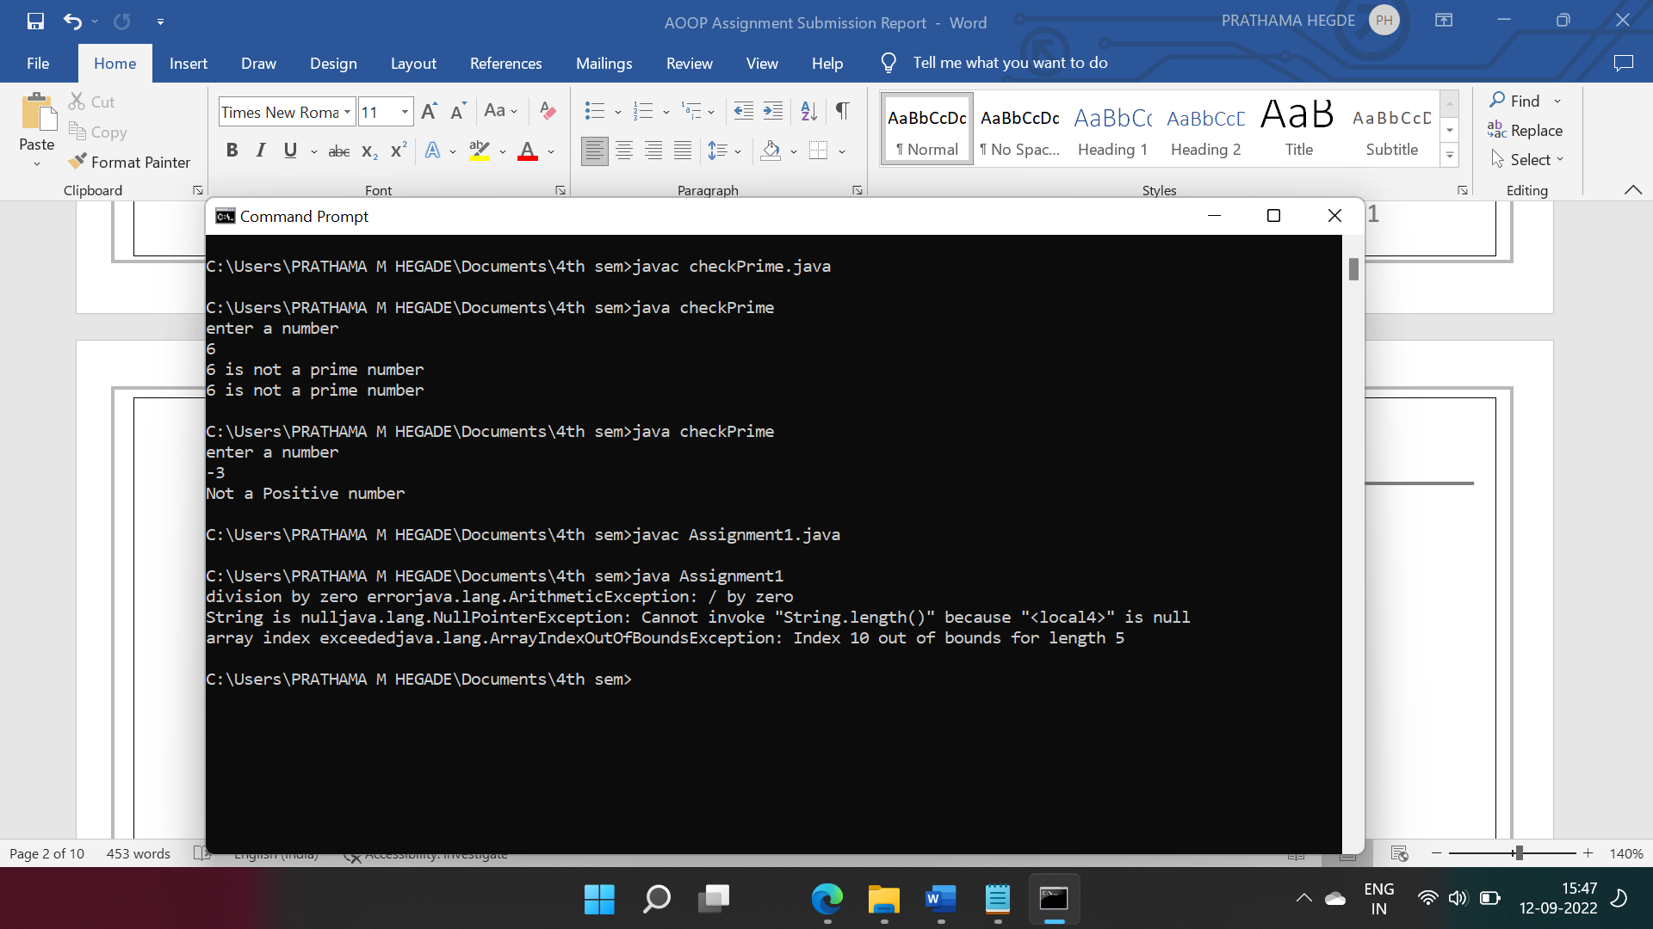

**1.Problem definition:**

2.Write a Java program to read an integer and check whether the number is prime or not. If negative number is entered, throw an exception NegativeNumberNotAllowedException and if entered number is not prime, then throw NumberNotPrimeException.

**2.Java Program:**

import java.util.Scanner;

import java.io.*;

class notPrime extends Exception{

public String toString(){

return "Not a Positive number";

}

}

class checkPrime{

public static void main(String[] args){

Scanner sc=new Scanner(System.in);

System.out.println("enter a number");

int n=sc.nextInt();

try{

if(n>0){

for(int i=2;i<=n/2;i++){

if(n%i==0){

System.out.println(n+" is not a prime number");

}

else{

System.out.println(n+" is a prime number");

}

}

}

else{

throw new notPrime();

}

}catch(notPrime np){

System.out.println(np.toString());

}

}

}

**3.Screenshot of excecution:**

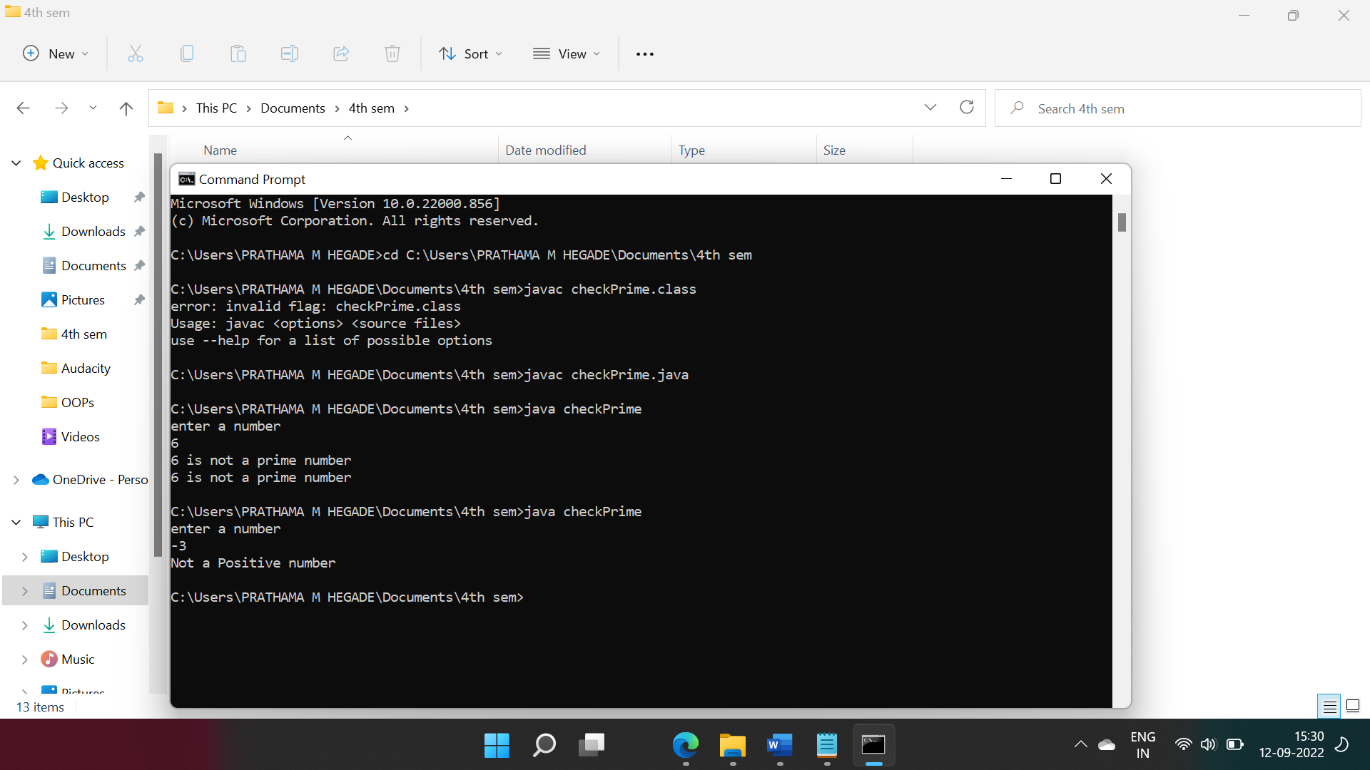

**1.Problem definition:**

3. Write a Java program to perform the following operations:

a) Read a line of text

b) Search for a sub-string SDMCET (case insensitive search)

c) If found, then print success message

d) Otherwise throw an exception SubStringNotFoundException with appropriate message

**2.Java Program:**

import java.io.BufferedReader;

import java.io.FileReader;

import java.io.IOException;

public class SubString {

public static void main(String args[]) throws IOException {

//File f=new File("sdmcet.txt");

FileReader f=new FileReader("Sdmcet.txt");

BufferedReader br= new BufferedReader(f);

String s1="SDMCET";

String s2="";

while((s2=br.readLine())!=null) {

try {

if(s2.contains(s1)) {

System.out.println("SDMCET string found succesfully at position:"+s2.indexOf(s1) );

}

else

throw new StringNotFoundException("String not found");

}catch(StringNotFoundException se) {

se.printStackTrace();

}

}

}

}

class StringNotFoundException extends Exception{

private String se;

StringNotFoundException(String s){

this.se=s;

}

**3.Screenshot of excecution:**

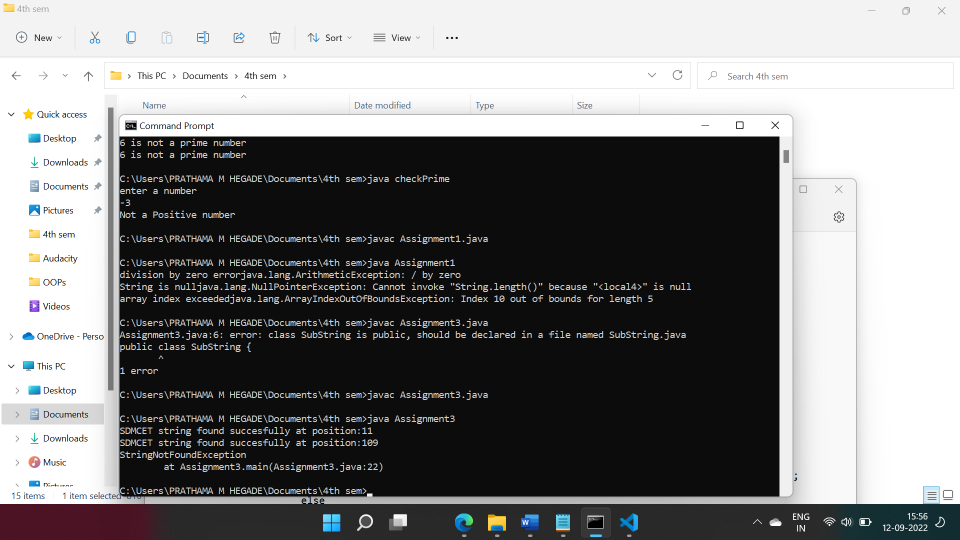

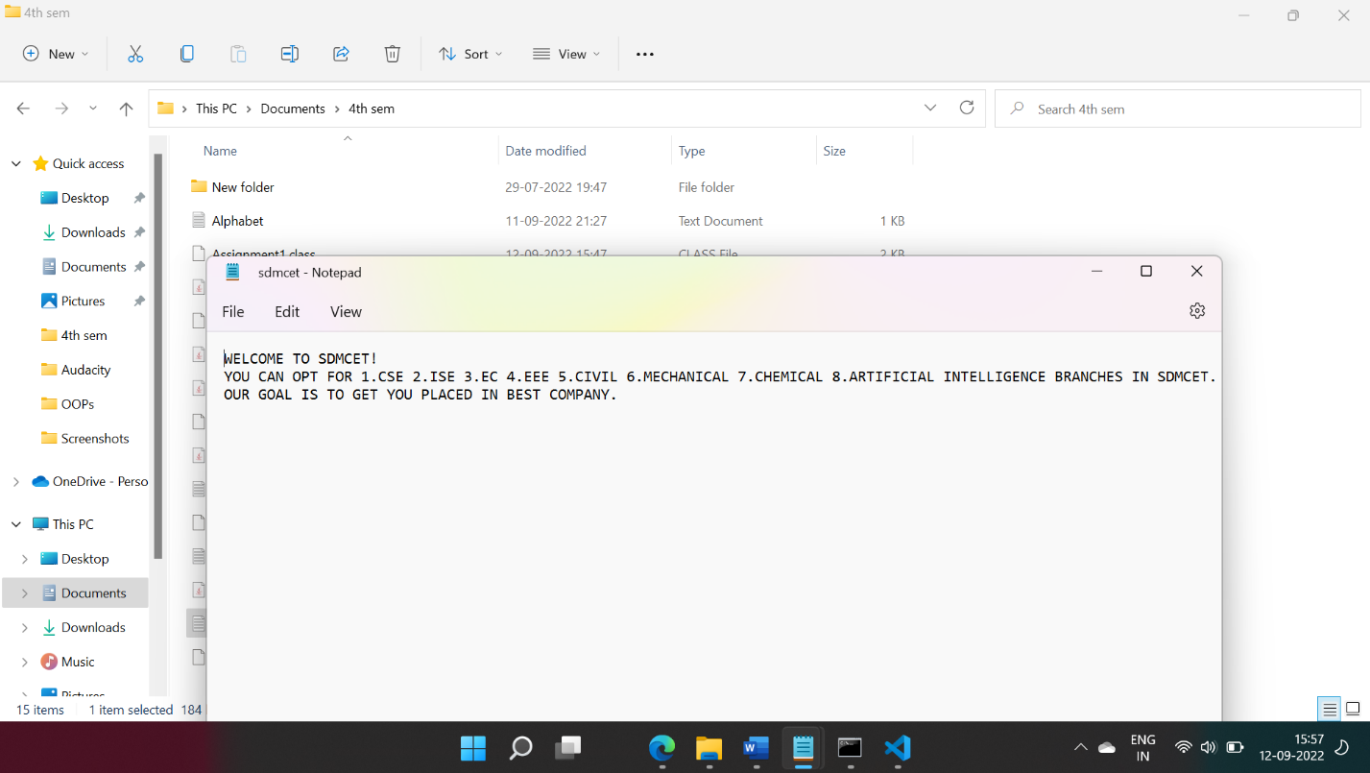

1. **Problem definition:**

4.Write a Java program to perform the following operations:

a) Create a file named Alphabets.txt and insert appropriate data into it

b) Read the file and copy all the consonants into another file named Consonants.txt

c) If vowel is encountered, throw an exception VowelNotAllowedException and continue until end of file

**2.Java Program:**

import java.util.*;

import java.io.*;

class Assignment4 {

public static void main(string[] args){

try{

FileInputStream fin=new FileInputStream("C:\Users\PRATHAMA M HEGADE\Documents\4th sem\Alphabet.txt");

FileOutputStream fout=new FileOutputStream("C:\Users\PRATHAMA M HEGADE\Documents\4th sem\consonant.txt");

int ch;

while(ch=fin.read()!=-1){

if(ch=='a'||ch=='e'||ch=='i'||ch=='o'||ch=='u'){

throw new vowelNotAllowedException();

}

else

fout.write(ch);

}

}catch(vowelNotAllowedException e){

System.out.println(e.toString());

}

}

}

class vowelNotAllowedException extends Exception{

public String toString(){

return "vowels are not allowed";

}

}

**3.Screenshot of excecution:**



